A modest proposal-1729, SWIFT
http://vimeo.com/4613163
http://it.wikipedia.org/wiki/Jonathan_Swift
Dublin, 30 November 1667 – 19 October 1745 , Anglo-irish, the first satirist in English language, essayist, pamphleteer, poet and cleric, remembered for The Gulliver’s Travel, An argument Against abolish Christianity. he is proposing to solve the problem of famine and hunger killing the 80% of all one-old-babies, and using them as food. Swift shows us with simplicity the tragic facts: thousands of people, especially children, are starving to death, partly because of the reader's indifference. the main oppressors of the poor were the landlords
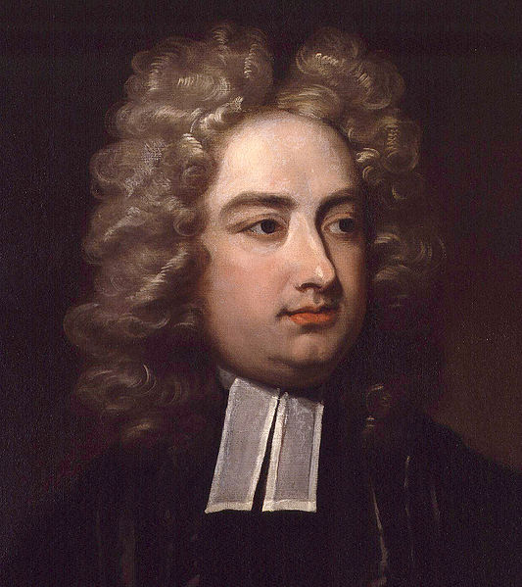
It’s an example of satiric device qith superb effect. He offers a starkly realistic although compassionate,

ALEXANDER POPE, The Rape of the Lock, il rapimento del ricciolo, a theft of a lock of a young woman's hair by an impassioned male admirer, Lord Petre, 5 cantos, an heroi-comical poem. the poem forces a continuous comparison between insignificant and significant things, offers an ironic perspective on contemporary manners combined with a deep appreciation for the vitality of the eighteenth-century beau monde, ladies and gentlemen are the heroines and heroes, Rather than gods and goddesses intruding in human affairs, sylphs and gnomes intervene
written in two cantos in 1712
http://it.wikipedia.org/wiki/Alexander_Pope
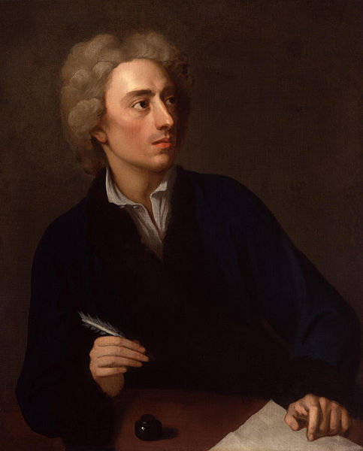
(21 May 1688 – 30 May 1744)catholic (1,37 cm) & so censured, is generally regarded as the greatest English poet of the eighteenth century; Modern critics consider The Rape of the Lock to be the supreme example of mock-heroic verse in the English language, Written in heroic couplets (distico eroico) addressed to John Caryll

William Wordsworth

http://it.wikipedia.org/wiki/William_Wordsworth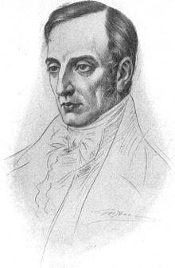
(7 April 1770 – 23 April 1850) was a major English Romantic poet who, with Samuel Taylor Coleridge, helped to launch the Romantic Age in English literature with the 1798 joint publication Lyrical Ballads . Wordsworth's magnum opus is generally considered to be The Prelude, a semiautobiographical poem of his early years which he revised and expanded a number of times. He insists on the morally influence of nature & love
HE visited nearby areas of France, Switzerland, and Italy.

"Lines Composed a Few Miles above Tintern Abbey"1798 and published as the last poem of Lyrical Ballads, he returned to the same place with his beloved sister, Dorothy Wordsworth
Published in 1798 in Lyrical Ballads, this poem is widely considered to be one of Wordsworth's masterpieces. It is a complex poem, addressing memory, mortality, faith in nature, and familial love. Wordsworth was inspired by the ideals of the Republican movement. Their emphasis on the value of the individual, imagination, and liberty inspired him and filled him with a sense of optimism. By 1798, however, Wordsworth was already losing faith in the movement, as it had by then degenerated into widespread violence. Wordsworth turns to nature to find the peace he cannot find in civilization. Wordsworth creates a sort of pact between Dorothy, the natural environment, and himself.Tintern Abbey was already just the ruins of a gothic cathedral--a stone shell with no roof, carpeted with grass. Although it is a romantic image, it is not the subject of the poem.
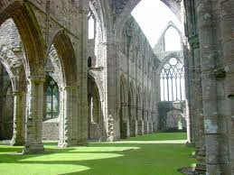

Ode: Intimations of Immortality from Recollections of Early Childhood
in the first stanza, the speaker says wistfully that there was a time when all of nature seemed dreamlike to him, “apparelled in celestial light,” and that that time is past; Wordsworth’s Immortality Ode, as it is often called, is written in eleven variable ode stanzas with variable rhyme schemes, in iambic lines with anything from two to five stressed syllables

John Dennis (1657 – 6 January 1734)

Joseph Addison
(1 May 1672 – 17 June 1719) Englishessayist, poet, playwright (dramatist)and politician. he first met Richard Steele, and at The Queen's College, Oxford, He encountered Jonathan Swift in Ireland . A dispute against Pope , he thinks that the imaginative faculty has been implanted in humankind by a loving Creator, revue with Steel The Spectator, the father of British journalism (60’000 copies) but Addison was often relegated
Sir Richard Steele (Dublin, bap. 12 March 1672 – 1 September 1729) was an Irish writer and politician, remembered as co-founder, with his friend Joseph Addison, of the magazine The Spectator. 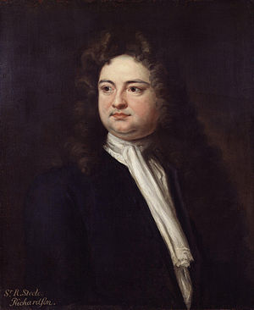
Daniel Defoe
ca. 1659–1661 to 24 April 1731^{[1]}), London, born Daniel Foe, was an English writer, journalist, and pamphleteer, who gained fame for his novel Robinson Crusoe. 1720-24, Moll Flanders 22 , Roxana 24, Colonel jack, Captain Singleton,
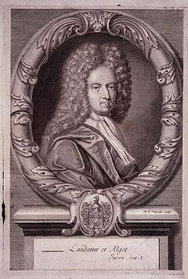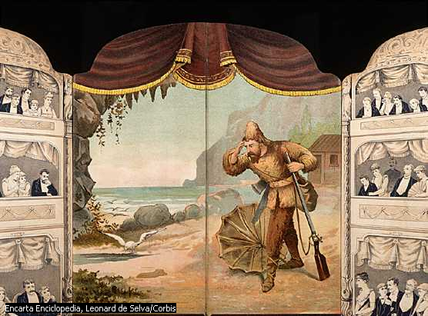
One of The earlier proponents of the NOVEL, he’s fascinated from the prosperity after the Glorious Revolution 1688 and the Act of Union and the Act of Union. His first literary success The true-born Englishman 1701 but he found the persecution , his pamphlet burned and he was imprisoned . After he became an undercover agent of the Government , monitoring Scottish responses to the proposed Union. Crusoe is of good family but not bred to any trade, so he goes to sea as an act of rebellion, to a state of grace. Friday is on on the Island with her father and a Spanish sailor rescued from the cannibals: Crusoe thinks to be the king of the isle with a Liberty of Conscience, tolerating pagan, Catholic, Protestant. He is a methodical diarist in a first-person narrative form.

Henry Fielding
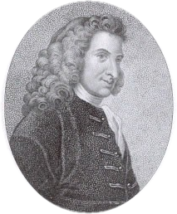
(Sharpham, 22 April 1707 – near Lisbon, 8 October 1754) was an English novelist and dramatist known for his rich earthy humour and satirical prowess, and as the author of the novel Tom Jones., the history of- 1749, with a instinctively gentle manner, for a broad reform of the society, of a human norm not an individual ideal.The nobility of “good nature”, a liberality of spirits, but with prudence & religion, Fiel analyzes the external characteristics of human being as a human norm.
Detractor of Pamela

Samuel Richardson

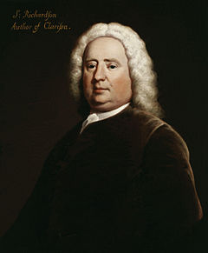
(19 August 1689 – 4 July 1761) was an 18th-century English writer and printer. He is best known for his three epistolary novels: Pamela: Or, Virtue Rewarded (1740),Clarissa: Or the History of a Young Lady (1748) and The History of Sir Charles Grandison (1753). Richardson was an established printer and publisher for most of his life and printed almost 500 different works, with journals and magazines.
Pamela was censured by the Vatican until 1900, Clarissa became famous too above all in France with a translation of abbé Prévost but also in a German & Dutch version, appreciated from Diderot and Rousseau and thanks to the first circulating library (public library): long missives for her worthy parents. Ric analyzes the inner characteristics of human being.

Laurence Sterne
(Clonmel Ireland 24 November 1713 – 18 March 1768) was an Anglo-Irish novelist and an Anglican clergyman. He is best known for his novels The Life and Opinions of Tristram Shandy ’68 , Gentleman, and A Sentimental Journey Through France and Italy 1766 but he also published many sermons, wrote memoirs, and was involved in local politics. Sterne died in London after years of fighting consumption. A sentimental..is a wonderfully various parody of the conventional travel-book, following Burton, Rabelais, Swift. A nonsensical, civil, good-humoured world.
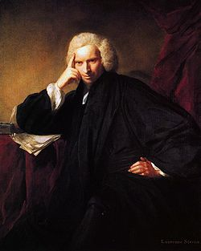
Gothic fiction, sometimes referred to as Gothic horror, is agenre or mode of literature that combines elements of both horror and romance. Gothicism's origin is attributed to English author Horace Walpole, with his 1764 novel The Castle of Otranto, subtitled "A Gothic Story", from Shakespeare and Spenser, following a medieval & national past, Macpherson’s Ossian, influencing Goethe, Schiller. From Burke idea of Sublime & Beautiful 1757”pain & terror are capable to produce delight. From the Castle of Otranto 1764, as delightful horror
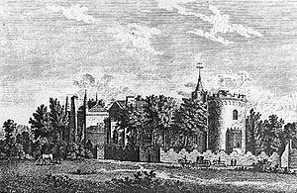
William Blake (London, 28 November 1757 – 12 August 1827) was an English poet, painter, and printmaker. Largely unrecognised during his lifetime, Blake is now considered a seminal figure in the history of both the poetry and visual arts of the Romantic Age.
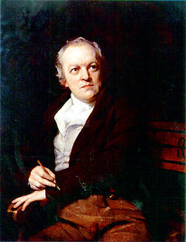
He takes sources from the Bible & the Bible-derived epic structured of Dante & Milton, Swedenborg, Watts, symbolism, imagery, prophetic uttering of the Bible, mysticism of Boehme with a God containing the germ of good & evil.”The song of Innocence.
George Gordon Byron, 6th Baron Byron, later George Gordon Noel, 6th Baron Byron, FRS (London, 22 January 1788 – 19 April 1824), commonly known simply as Lord Byron, was an English poet and a leading figure in Romanticism
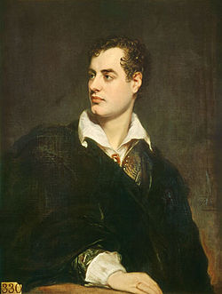
“Childe Harlod” 1812 (about Greece decaying against Ottomans) an immediate celebrity as voice of post-Revolutionary era, like Scott. Modern, extravagant, his muse is not nature but public life, a feverish nationalism after the Revolution, melancholic, libertarian & libertine. A Rousseauistic faith in basic human goodness.Companion of Percy Bysshe Shelley. Atheist against Christianity “the necessity if atheism” & so he was expelled from the university, the Universe as a whole
Percy Bysshe Shelley 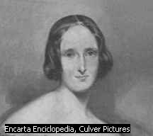 ( /ˈpɜrsi ˈbɪʃ ˈʃɛli/;^{[2]} 4 August 1792 – 8 July 1822) was one of the major English Romantic poets and is critically regarded among the finest lyric poets in the English language. Shelley was famous for his association with John Keats and Lord Byron. The novelist Mary Shelley was his second wife.
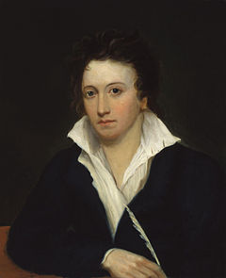
Adonais 1812 to the dead Keats, the poet as a hero
John Keats ( /ˈkiːts/; 31 October 1795 – 23 February 1821) was an English Romantic poet. Along with Lord Byron and Percy Bysshe Shelley, he was one of the key figures in the second generation of the Romantic movement, despite the fact that his work had been in publication for only four years before his death.^{[1}
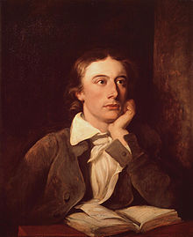

“Endymion” Isabella”

Ode to a Nightingale With “Ode to a Nightingale,” Keats’s speaker begins his fullest and deepest exploration of the themes of creative expression and the mortality of human life, speaking about Indolence.
- As in "Ode to a Nightingale," the poet wants to create a world of pure joy, but in this poem the idealized or fantasy world is the life of the people on the urn. the discrepancy between the urn with its frozen images and the dynamic life portrayed on the urn,
- the human and changeable versus the immortal and permanent,
- participation versus observation,
- life versus art.
In "Ode on Melancholy" Keats accepts the truth he sees: joy and pain are inseparable and to experience joy fully we must experience sadness or melancholy fully. This ode expresses Keats's view wholeheartedly; it differs significantly from "Ode to a Nightingale" and "Ode on a Grecian Urn," in which the poet-dreamer attempts to escape from reality into the ideal and unchanging world of the nightingale and the urn.
Jane Austen (16 December 1775 – 18 July 1817) was an English novelist whose works of romantic fiction, set among thelanded gentry, earned her a place as one of the most widely read writers in English literature, her realism and biting social commentary cementing her historical importance among scholars and critics
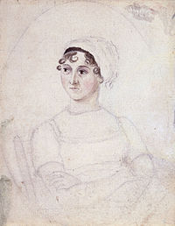
Moral message of good conduct, good manner, marriage as a good social institution but her heroines are vivaciously intelligent as Elisabeth Bennet or witty , egotistic & independent as Emma Woodhouse or passive as Fanny Price. Pride & Prejudice 1813 is an example to pain, humiliation, and detachment. Cleverness, wit, spontaneity are never allowed. In Emma 1814. A certain anti-romanticism is evident in Mansfield Park.
Sir Walter Scott 1771-1832 Edimburgh, anti-tory & Unionist,he invented a scotch tradition, he influenced European & American literature, first poet with Waverley anonymous , ballads Minstrelsy of the Scottish Border 1802-3, translated Goethe & German Ballads but above all THE 18TH century HISTORICAL NOVEL.
Ivanohe 1820, about medieval code of chivalry & military honour.
Dickens, Charles (Portsmouth 1812 - Gad's Hill, Kent 1870
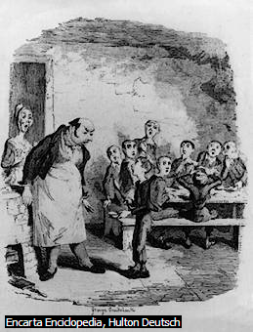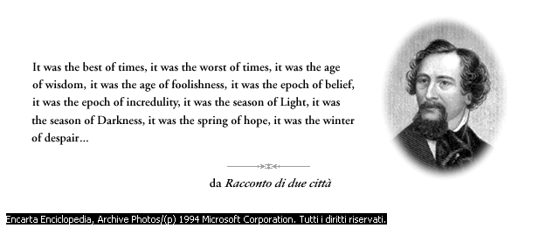
He read The French Revolution 500 times, a Tale of two cities, Hard Times, Bleak House: Victorian period, Christian as a moral basis, but a potential humour anarchy. “the Pickwick Papers” 1836-7 “Oliver Twist” 37-8, a popular novel against bourgeois respectability; “David Copperfield” 1840-50 1840-50 , “hard times” 54 about the industrial Revolution,” greet expectations” ,. He’s not a pure Realist but a characters writer.
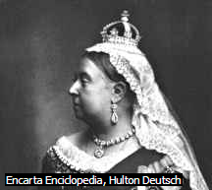 queen Victory, (Londra 1819 - Osborne, Isola di Wight 1901),reign from 1837 to 1901
Thackeray, William Makepeace (Kolkata –India 1811 - Londra 1863),e English victorian writer, “the memoirs of Berry Lindon” 1852, Thackeray’s narrator is an Irish adventurer who deserts the Seven Years war, working as gambler in courts & spas, “Vanity Fair” 1847-8 a novel without a hero.
Brontë, Charlotte (Thornton, Yorkshire 1816 – Haworth, Yorkshire 1855), late Romanticism, “The Professor”1846, “Shirley””Villette”Jane Eyre “ ’47 autobiography written in 3 weeks, realist fiction, the heroin suffers as a man, but for an Anglican marriage (I do) in replay to Rochester’s passionate question, secular happiness as a means of salvation.

Anne Bronte’s” Agnes Grey” ; with pseudonyms; “The tenant” 48 : an unhappy marriage & the escape by its heroine.
Emily “Wuthering Heights” Cime tempestose, a rustic novel, illicit relationships, wild landscapes, tempestuous climatic conditions, but the most unconventional & demanding of all English novels. An evocation of freedom, gothic & psychological, Original, realistic but also symbolic, When she died refused doctors & medicines. Father was a parish (Irish origin).
Tennyson, Alfred (Somersby, Lincolnshire 1809 - Aldworth, Surrey 1892, English poet, 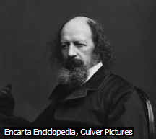
“The Lady of Shalott”” Ulysses”. Second generation of Romantics, melancholic, an age dominated by the machinery: “the ballad of Oriana” In memoriam” 50, “the passing of Arthur”.
Pre-Raphaelite Brotherhood, parnassian mode: Dante Gabriel Rossetti((London 1828 - Birchington-on-Sea 1882), english poet & painte), Millais, Christina Rossetti sister of Dante… to revolutionize the pictorial arts in 1848, before the Rennaissance, before the time of Raphael, looking for the Nazaren painters in Germany. Christ over the pinnacle of heroes, Chaucer, Shakespeare, Keats. Rossetti idealizes women both sexually and spiritually. The Germ , their journal.
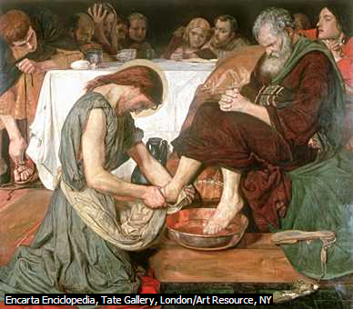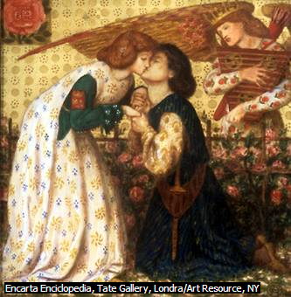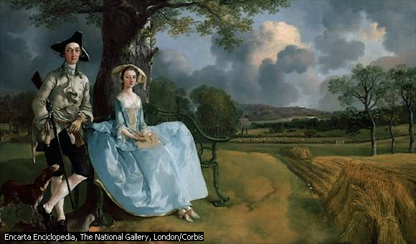
Ruskin, John (Londra 1819 - Coniston, Lancashire 1900 British writer & critic, friend of Rossetti e Millais, he sustained tha painter (“Modern Painters”43) Turner Joseph Mallord William (Londra 1775-1851 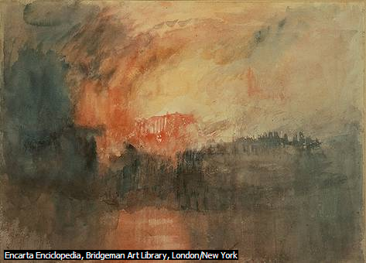
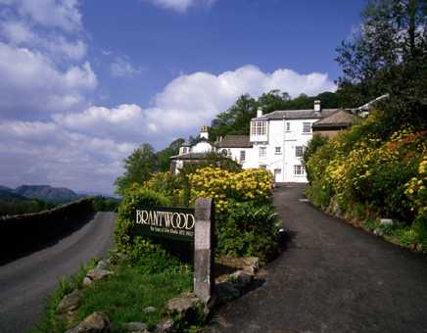
David Ball/The Stock Market
Casa di John Ruskin, Brantwood
the Brownings, Robert Robert (Camberwell, Londra 1812 - Venezia 1889)”the ring & the book”68-69 differs radically from his wife
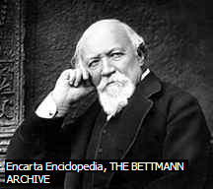
& Elisabeth Barrett Browining’s (a feminist statement) passionate outpouring(sfogo) of love-poetry in the Sonnets from the Portuguese , written during the courtship of two poets, following a decision to live in Italy, analyzing social & political nationalism .
Eliot, George Pseudonimo di Mary Ann, o Marian, Evans 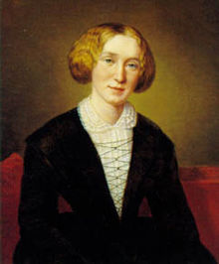 (Arbury Farm, Warwickshire 1819 - Londra 1880, English mid-Victorian writer “scenes of clerical Life, 57”Adam Bede” 59 read by the queen. She remoulds the best of Scott’s work, gaining social respect bit godless Marian Evans (pseudonym)affronted her & she eclipsed. He translated a Critic of Bible of Strauss ’46 (Strauss, David Friedrich (Ludwigsburg 1808-1874), teologo e filosofo Tedesco, antievangelico) but also The essence of Christianity of Schopenhauer 54 but also Comte. “middlemarch” 71-2. He commented Comte & Darwin .
Pater, Walter Horatio (Shadwell, Londra 1839 - Oxford 1894 english critic & essayst “studies in the History of the Renaissance 73, Marius the epicurean 85.,English writer & poet, “churchy”
Thomas Hardy (Upper Bockhampton, 2 giugno 1840 – Dorchester, 11 gennaio 1928) 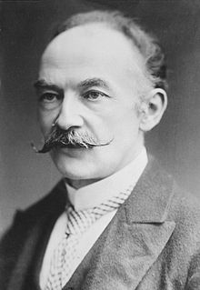
Jude the obscure 95, he liked Schopenhauer, Darwin, post-Victorian, “The trumpet major 80” historical novel
Robert Louis Balfour Stevenson (Edimburgo, 13 novembre 1850 –Vailima, 3 dicembre 1894, Scottish writer 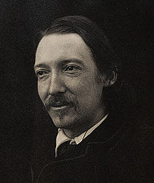 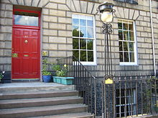 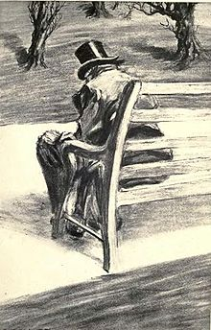He used the Scot vernacular, The strange case of Dr Jeckyll & Mr Hyde 1886 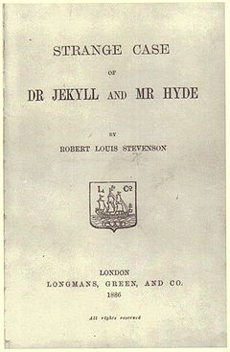 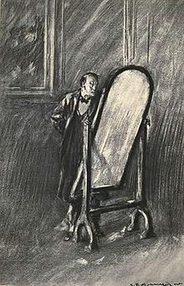
The respectable dr Jeckyll & his alter ego Mr Hyde, to Jec suicide as unique release. Scotland a nation riven by Jacobite divisions (it was the political movement in Britain dedicated to the restoration of the Stuart kings).
Joseph Conrad (born Józef Teodor Konrad Korzeniowski;^{[1]} 3 December 1857 – 3 August 1924) was a Polish-born English novelist of the sea-stories and he first attracted public attention. They concern with the nature and effects of European imperialism “lord Jim”1900, in the name of duty of sacredness & civilizing work bringing light & faith in the “darkness”, Heart of Darkness ’99.
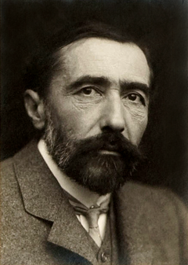
Oscar Fingal O'Flaherty Wills Wilde (Dublino, 16 ottobre 1854 – Parigi, 30 novembre 1900) irish writer,poet & dramatist
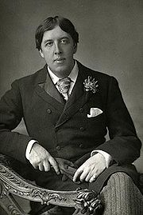 http://www.stulfa.it/viaggi/irlanda/irlanda.html
Nationalist, he studied at Oxford, homosexual like a french decadent, imprisonment 95 because of homosexual practices & removed from the theatres (“An ideal husband”) . His art is subversive, it’s for more than an imitatation of Nature, the untrue is the aim of Art. Socialism aim is a mere enjoyment. The picture of Dorian Gray ’90 (preface “all art is quiet useless). Art & morality are quiet divorced, a Faustian demonstration of that. of that. Hedoninsm both indulged than disdained, it’s a tragedy self-destructive, a desperate suicide & martyr. First play “ Vera & the Nihilists 1880 following the Russian political realities. First blank verse The duchess of Padua written in Paris in 83, Florentine Targedy 94 but above all Salome 94 written in French & translated in English by a lover , published only in 1931 in England & transformed in Germany in ’15 becoming the libretto of R. Strauss’s revolutionary opera. The importance of Being Earnest 95, Lady Windermere’s fan 92 the first supreme success on the London stage. A pure aristocratic dandy.
Yeats, William Butler (Sandymouth, Dublino 1865 - Roquebrune-Saint-Martin, Francia 1939), Irish poet & dramatist, for a Irish theatrical Renaissance, he wrote to the mother/father figure of the Celtic & Catholic conversion revival, the Scottish writer Fiona Macleod pseudonym of William Sharp, for a symbolic Celtic setting against the drab materialism & Ibsen common realism, “The Countess Kathleen” 92 to inaugurate the Irish Literary Theatre in 99, in Abbey Theatre in Dublin. His personage is the ancient hero Cuculhaon in On Baile’s Strand. With experimental instruments in the scene (drums, gong etc) to recreate a ritual dance, mystical sensuality & sexuality as a new Romantic ( from Blake & Rossetti). Nobel 23, Theosophy, Kabalah, occultism, foreign literature. Buried close to Sligo. He had been inspired from Debussy.
Woolf, Virginia (Londra 1882 - Rodmeil 1941 suicide 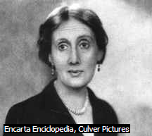, English writer & essayist, he suggests to convey an impression of luminous halo of life in the new novel against Edwardian materialist novelists but following Joyce & Lawrence “to the Lighthouse” 27. It was the period post-Darwinism & the Freudian theory. 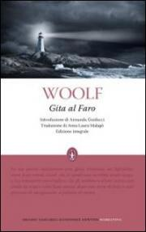 http://www.stulfa.it/viaggi/england/sidmouth.html
Stream of consciousness , essay Modern Fiction, influenced from Bergson & Proust. Godless. “The years” 37. “orlando” ’28.
David Herbert Richards Lawrence (Eastwood, 11 settembre 1885 – Vence, 2 marzo 1930) 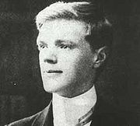
The self-proclaimed apostle of new literary & moral freedoms , son of a miner, free elementary school’ act, ha Modernist theology, an oracular witch relies less on the death of God than on the advent of a Godless prophet, Freud. For a liberation of sexuality “psychoanalysis & Unconscious”21 &”fantasia & Unconscious”22 ,he’s the inheritor of Romantic prejudices against machines. “Rainbow” “Women in love””lady Chatterley’ s lover” after a failed persecution under the Obscene Publications Act.
Thomas Stearns Eliot (Saint Louis, 26 settembre 1888 – Londra, 4 gennaio1965 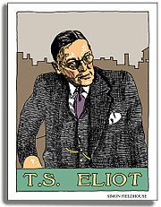 was a playwright, literary critic, and arguably the most important English-language poet of the 20th century.^{[3]}Although he was born an American he moved to the United Kingdom in 1914 (at age 25) and was naturalised as a British subject in 1927 at age 39.
The waste land 1931, the disillusionment of a generation which is non sense; the first English poet did not write it as Englishman, & like Ezra Pound, he is American resident in London, he attended lectures of Bergson & knes Fournier & the catho-monarchist Maurras, Dante, Laforgue & his free-verse dramatic monologues but also Baudelaire & his modern poetry, “ the thought may be obscure”, Harvard doctoral thesis about Bradley. The Love Song of J. Alfred Prufrock 10 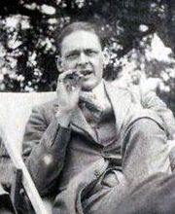
He apprecieted the mystical Yeats¸ anglo-catholic. “nocturne” ’09, “The long Song of J.Alfred Prufrock”’11 to Ezra Pound, “Tradition and the Individual Talent”.
James Augustine Aloysius Joyce (Dublino, 2 febbraio 1882 – Zurigo, 13 gennaio 1941) 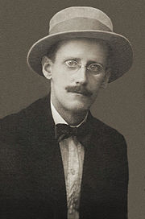 Dubliner poet & writer. Eliot proclamed Joyce the best living prose writer above all “Scylla & Charybdis” in Ulysess, but “Dubliners” ’05 was rejected in London, written in Trieste, the main port in Austria-Hungary: Dublin as centre of paralysis.”Ulysses”, once conceived as a story of Dubliners, a troubled Stephen Dedalus (the lost son of Uly, Thelemachus) has returned to his birthplace, Uly has a multiple focus, against the earthier preoccupations of Leopold Bloom (as Odysseus/Ulysses) a Dublin Jew & his consciousness contrasting with his wife Molly (as Penelope), staying always in her bed, also with a lover, with a unpunctuated monologue. Like an Homeric precedent. From Realism to Absurdity
Aldous Leonard Huxley (Godalming, 26 luglio 1894 – Los Angeles, 22 novembre 1963) 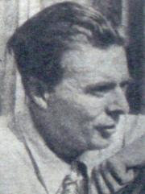English writer “Brave new world” an utopian novel ’32

Wystan Hugh Auden (ˈwɪstən hjuː ˈɔːdən) (York, 21 febbraio 1907 – Vienna,29 settembre 1973) 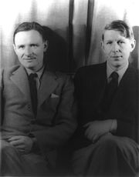 precoce
The Auden Cercle ,homosexual (he married the T.Mann’s daughter for escaping from Germany during the war,) socialist,Marxist, & then Christian after World (Kierkegaard, mystic) , for a modern literary approaching & emancipation, Freudian. “ The Waste land” “letters from Iceland “37.
George Orwell, pseudonimo di Eric Arthur Blair (Motihari, 25 giugno 1903 –Londra, 21 gennaio 1950)
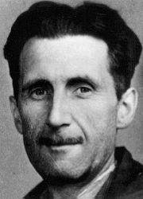  animal farm
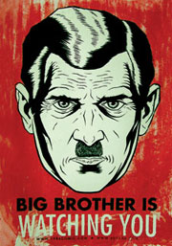 English Writer & journalist ,he investigated the social slums,with a profound disillusion with soviet Communism ‘cause Stalin has betrayed a human ideal, against totalitarianism for a democratic socialism . “Homage to Catalonia” 38. “Animal farm” 45, a satire on the manifest failure of Communist ideals in Russia

The New Theatre
John James Osborne (12 December 1929 – 24 December 1994) was an English playwright, screenwriter, actor and critic ofthe Establishment. The success of his 1956 play Look Back in Anger transformed English theatre. “look back in Anger” 56 marked a revolution , Rattingan an innovator & a dramatist, a cerebral writer , Christopher Fry (18 December 1907 – 30 June 2005) was an English playwrigh, looking for Sartre, Brecht (Mother Courage), Beckett “waiting for Godot” 55.
Samuel Barclay Beckett (Dublino, 13 aprile 1906 – Parigi, 22 dicembre 1989)
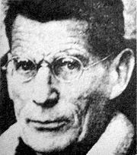 Protesatant avant-garde novelist, playwright, theatre director, and poet.

George Bernard Shaw (Dublino, 26 luglio 1856 – Ayot St Lawrence, 2 novembre 1950) Irish dramatist & writer 